**Gentle Fun Exercise**

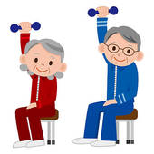

**Healthy Heart**  
**Balance   
Fun Feel Good**  
**Lose Weight  
Music Socialise  
Healthy Bone** Mobility Relaxation

**Get active with us!**

**At Farley Park Community Centre Whitehall Rd, West Bromwich B70 0HJ  
Every Tuesday – 10-11am**

**£2.00 per session (First free!)**

**Join our weekly gentle chair aerobics & some standing (optional) exercise sessions for the over 50’s and less able of all ages. You’ll soon notice a difference in your health and mobility – and you’ll have some fun too! For more information Contact Saba- 07983577299**